ER Inversion Example: Imaging Two Blocks

Overview
This tutorial builds upon the two_blocks examples presented in the mesh generation and forward modeling tutorials. The jupyter notebook ERT3_two_blocks.ipynb takes the user through the steps in this tutorial. The file clear_files.ipynb resets the directory to contain files before running ERT3_two_blocks.ipynb
All files have been generated and stored in .tar.gz files. These are named:
inv_1.tar.gz
inv_2.tar.gz
inv_3.tar.gz
inv_4.tar.gz
A jupyter lab notebook is provided within each of these unzipped directories and show visualization of the results for each of the inversion options specified.
In the two blocks tutorial(mode_ERT1/two_blocks), we constructed a computational mesh composed of two blocks embedded within an otherwise homogeneous halfspace. The conductivity of the halfspace was 0.002 S/m, and the conductivity of the left and right blocks were 0.02 S/m and 0.2 S/m, respectively, as shown in Figure 1. This represents the true model and the target for the synthetic ERT imaging in this tutorial.

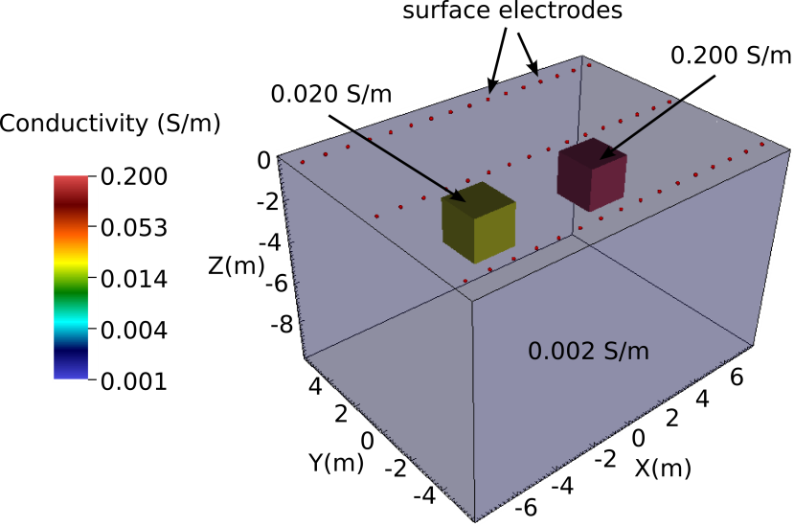
Figure 1. True subsurface conductivity distribution
In the two blocks forward model (mode_ERT2/two_blocks/Example 2), we used E4D forward modeling capabilities to generate a synthetic survey file named two_blocks.sig.srv. To simulate field conditions, we added random noise to the transfer resistance measurements in two_blocks.sig.srv , adjusted the standard deviations accordingly, and renamed the survey file to two_blocks.srv, which is the survey file used in this tutorial (note: noise addition was done outside of E4D and was not shown in the previous tutorial).
To further simulate realistic field conditions, we assume in this tutorial that the locations and dimensions of subsurface anomalies are unknown, and build a mesh consistent with that assumption. That is, for the inversion problem, we build a mesh with no implicit internal boundaries. To do so, we simply modify the mesh configuration file two_blocks.cfg by removing the subsurface boundary definitions for the two blocks. This results in two zones in the inversion mesh; a foreground zone containing the electrodes and target imaging volume (zone 1), and a zone of elements extending to the mesh boundaries (zone 2). The modified mesh configuration file used to build the mesh is named two_blocks_inv.cfg, and is included in this directory of the E4D distribution. Users are encouraged to review ERT1 and ERT2 tutorials and build the mesh for this example using two_block_inv.cfg, thereby generating the mesh files two_blocks_inv.1.node, two_blocks_inv.1.ele, two_blocks_inv.1.face, two_blocks_inv.1.neigh, and two_blocks_inv.trn. A cut-out view of the resulting mesh is shown in Figure 2.

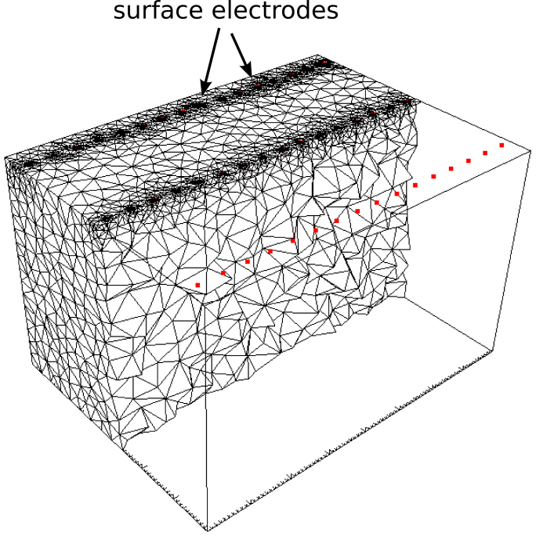
Figure 2. Cut-out view of the inversion mesh, which is refined around electrodes anddoes not include the block boundaries, and is coarser than the forward modeling mesh (Figure 1).
With the exception of the mesh files, the directory for this tutorial contains all of the files necessary to execute the inversions demonstrated in this example. This includes the four inversion options files two_blocks_1.inv, two_blocks_2.inv, two_blocks_3.inv, and two_blocks_4.inv. Each inversion option file builds upon the previous by adding constraint blocks that represent some additional a priori information about the subsurface conductivity, thereby providing improved resolution with each subsequent inversion.

Smoothness Constrained Inversion
Smoothness constraints or similarity constraints are the most common constraints applied in ERT inversion problems, and are based on the hypothesis that neighboring elements are likely to have similar conductivity values. According to Occam's Razor, in the absence of constraining information other than transfer resistance measurements, the inverse solution that honors the measurements and has the least amount of heterogeneity is the most likely solution. Hence, smoothness constrained inversions are also called Occam's inversions. In E4D, smoothness constraints are specified by choosing a structural metric and weighting function that encourages the inversion to minimize the difference between neighboring elements, regardless of the conductivity values of those elements. Structure metric 2 provides the absolute difference between the log conductivity values of neighboring elements, and is the recommended metric to use for implementing smoothness constraints. Weighting function 1 will apply full weight to structure metric 2 if a large value is specified for the weighting function mean, so that the value of the weighting function never reduces from unity for reasonably expected conductivity differences between neighboring elements.
In this example, we implement smoothness constraints as described above. Below we provide the e4d.inp file and the inverse options file for discussion.

E4D Run File: e4d.inp

<begin e4d.inp> this line is not included in the file
ERT3 run mode
two_blocks_inv.1.node mesh node file name
two_blocks.srv survey file name
'average' use the average apparent conductivity for the starting model
two_blocks.out output options file
two_blocks_1.inv inverse options file
none reference model file (no reference model specified two_blocks.1.inv)

Notes: The mesh files and survey file are created as described in the Overview section. The inversion options file is shown below.
<end e4d.inp> this line is not included in the file

Inversion Options File: two_blocks_1.inv

<begin two_blocks_1.inv> this line is not included in the file

2 # of constraint blocks, this file implements
1 constrain zone 1 with this block
2 1.0 1.0 1.0 structural metric 2 (wx wy wz ignored)
1 10.0 .01 weight func. 1 with mean of 10 and small s.d.
1 2 one link to zone 2
0.0 reference value (not used)
1.0 relative weight
2 constrain zone 2 with this block
2 1.0 1.0 1.0 structural metric 2 (wx wy wz ignored)
1 10 0.01 weight func. 1 with mean of 10 and small s.d.
0 no links (already linked to zone 1 above)
0.0 reference value (not used)
1.0 relative weight
100 0.25 0.5 beta min_red beta_red
1.0 chi_targ
30 50 miniter maxiter
0.00001 1.0 minsig maxsig
2 up_opt
1 3.0 cflag cdev
Notes: This inversion options file implements an Occam's type inversion by specifying similarity constraints between neighboring elements (structural metric 2) that are not removed unless the difference
between neighbors is extreme. That is, the weight on the similarity constraints will not be reduced unless the absolute difference in log conductivity between neighbors exceeds 10, as specified by the weighting function. Zone 1 is linked to zone 2, which specifies that similarity constraints should be applied at the zone 1/zone 2 boundary. Since zone 1 is linked to zone 2, it is not necessary to link zone 2 to zone 1. Hence, zone 2 is not linked to another zone.

<end two_blocks_1.inv> this line is not included in the file

Running the Inversion
The inversion was executed for this example on 7 cores (1 master and 6 slave) using the command:
<e4d_dir>/bin/mpirun -np 7 <e4d_dir/bin/e4d>.
Or, if mpirun and e4d are in the exectuable path:
mpirun -np 7 e4d.
Upon execution, E4D completes the inversion and reports progress to the following files:
e4d.log: This is primary log file discussed in the next section.
run_time.txt: This file contains run-time information and is updated as the inversion progresses
two_blocks.dpd: This is the predicted data file specified in the output option file two_blocks.out
sigma.* Estimated conductivity at the *th inverse iteration.
Status updates are also printed to screen. With the specified mesh and settings, the inversion converged in seven iterations, requiring approximately 10 minutes to complete on a laptop computer with 8 processing cores and 4 Gb of RAM.

E4D Log File: e4d.log
The E4D log file records information describing the inversion parameters and performance, and is updated as the inversion progresses. Users are encouraged to run the inversion as described above, and review the log file. The first block of the log summarizes mesh, survey, and inversion information, and is relatively self-explanatory. For the sake of discussion, we provide excerpts from the log file below, including the iteration records for several iterations.

Iteration 0: Starting model

<begin e4d.log> this line is not included in the file
.
.
.
********** CONVERGENCE STATISTICS AT STARTING MODEL *******************
Phi_dat Phi_Mod Phi_Mod/Beta Phi_Tot
31530. 0.0000 0.0000 31530.
Total Number of Constraint Eqs: 0000242717
Block # Constraints % of Total Error Error per Constraint
1 157537 0.0000 0.0000
2 85180 0.0000 0.0000
Chi2 is currently 15.53 Target value is 1.0000
Mean error is 0.6170
RMS error is 3.941
Number of data culled is 0000040
Prior to data culling ...
Chi2 is 29.31
Mean error is 0.4395
RMS error is 5.414
******************************************************************************
.
.
.
<end e4d.log> this line is not included in the file

The starting model is homogeneous with a conductivity of 0.00219 S/m, which is the average apparent conductivity computed by E4D, and is reported in e4d.log (not shown). As shown above, the data norm of the objective function at the starting model is 31350, which reflects the weighted misfit between observed and simulated data. The model norm of the objective function is zero because the starting model is homogeneous, causing the constraint equations specified for each of the constraint blocks to be perfectly minimized in this case. Block 1 contains more constraint equations than block 2 because there are more elements in block 1 than block 2. There are 40 data points culled, meaning that 40 of the weighted transfer resistance residuals are outside of the specified data culling bounds, which is three standard deviations from the mean weighted residual in this case. Without the 40 culled data points, the chi-squared value at the starting model is 15.53. The target value is 1.00 as specified in the inverse options file. Convergence statistics prior to data culling are also printed as a reference.

Iteration 1

<begin e4d.log> this line is not included in the file
.
.
.
********** CONVERGENCE STATISTICS AFTER INVERSE UPDATE # 001 **********
Phi_dat Phi_Mod Phi_Mod/Beta Phi_Tot
5311.6 2928.4 29.284 8240.0
Total Number of Constraint Eqs: 0000242717
Block #Constraints % of Total Error Error per Constraint
1 157537 81.344 0.70122E-02
2 85180 18.656 0.29744E-02
Chi2 is currently 2.600 Target value is 1.0000
Mean error is -.3537
RMS error is 1.612
Number of data culled is 0000027
Prior to data culling ...
Chi2 is 4.594
Mean error is -.4862
RMS error is 2.143
*********************************************************************************************************
Decrease in objective function is: 0.7387
Decrease in objective function is sufficient to continue at beta = 100.0
.
.
.
<end e4d.log> this line is not included in the file
After the first iteration, the chi-squared value dropped by approximately 74% from the starting model, indicating a significant improvement in the data fit. The constraint block errors indicate the degree to which the model constraints are honored. Zone 1 has a greater degree of misfit, indicating a greater degree of heterogeneity. This is expected, since the data are primarily sensitive the conductivity in zone 1. The number of culled data has dropped from 40 at the baseline model to 27 after iteration 1. The objective function decreased by more than 0.25 (or 25%), so the beta value was not reduced.

Iteration 6

<begin e4d.log> this line is not included in the file
.
.
.
********** CONVERGENCE STATISTICS AFTER INVERSE UPDATE # 006**********
Phi_dat Phi_Mod Phi_Mod/Beta Phi_Tot
2364.6 1853.9 74.155 4218.4
Total Number of Constraint Eqs: 0000242717
Block #Constraints % of Total Error Error per Constraint
1 157537 82.813 0.10484E-01
2 85180 17.187 0.40242E-02
Chi2 is currently 1.159 Target value is 1.0000
Mean error is -.5535
RMS error is 1.077
Number of data culled is 0000030
Prior to data culling ...
Chi2 is 2.23
Mean error is -.6552
RMS error is 1.493
*********************************************************************************************************
Decrease in objective function is: 0.3157E-02
Solution did not converge at beta = 25.00
Decreasing beta by 0.5000 from 25.00 to 12.50
.
.
.
<end e4d.log> this line is not included in the file
The inversion required 7 iterations to converge. Iteration 6 is shown above. At iteration 6, the chi-squared value is near the target value. The Phi_Mod/Beta value increased from approximately 29 to 74 between iteration 1 and iteration 6, indicating increased heterogeneity in the model. The objective function decreased by less than 0.25 during this iteration, so the beta value decreased for the next iteration.

Inversion Image
Figure 3 shows the final solution for the smoothness constrained inversion. The visualization was produced using VisIt. The location of both blocks are clearly evident, although both are smoothed, or blurred, as expected. The relative conductive magnitudes of each block are also evident.

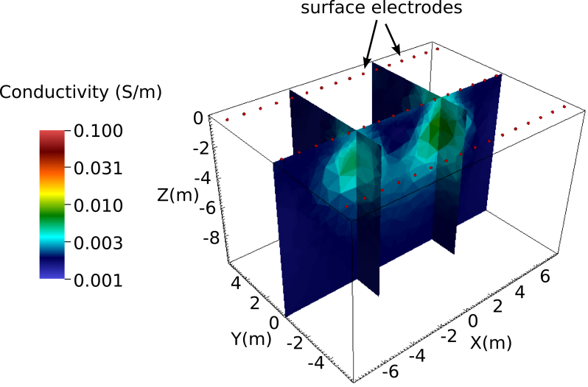
Figure 3. VisIt visualization of the smoothness constrained inversion results

Smoothness Constrained Inversion + Minimum Conductivity Constraint
In this example, we assume it is known that the subsurface conductivity is greater than or equal to 0.002 S/m within the imaging zone, and we apply an additional constraint block instruction in E4D to enforce that condition in the inversion. The inversion options file with the new constraint is included with the E4D distribution as two_blocks_2.inv, and is shown below for discussion. To use the constraints specified in two_blocks_2.inv, simply modify the e4d.inp file listed above so that two_blocks_2.inv is specified on the inversion options file line instead of two_blocks_1.inv.

Inversion Options File: two_blocks_2.inv
<begin two_blocks_2.inv> this line is not included in the file

3 # of constraint blocks, this file implements
1 constrain zone 1 with this block
2 1.0 1.0 1.0 structural metric 2 (wx wy wz ignored)
1 10.0 .01 weight func. 1 with mean of 10 and small s.d.
1 2 one link to zone 2
0.0 reference value (not used)
1.0 relative weight
2 constrain zone 2
2 1.0 1.0 1.0 structural metric 2 (wx wy wz ignored)
1 10 0.01 weight func. 1 with mean of 10 and small s.d.
0 no links (already linked to zone 1 above)
0.0 reference value (not used)
1.0 relative weight
1 constrain zone 1 with this block
3 1.0 1.0 1.0 structural metric 3 (wx wy wz ignored)
1 0 .1 weight func. 1 with mean of 0.0 and s.d. of 0.1
0 no links
0.002 reference value S/m
2 relative weight
100 0.25 0.5 beta min_red beta_red
1.0 chi_targ
30 50 miniter maxiter
0.00001 1.0 minsig maxsig
2 up_opt
1 3.0 cflag cdev
Notes: This inversion options file implements an Occam's type inversion by specifying similarity constraints between neighboring elements (structural metric 2) that are not removed unless the difference
between neighbors is extreme. That is, the weight on the similarity constraints will not be reduced unless the absolute difference in log conductivity between neighbors exceeds 10, as specified by the weighting function. Zone 1 is linked to zone 2, which specifies that similarity constraints should be applied at the zone 1/zone 2 boundary. Since zone 1 is linked to zone 2, it is not necessary to link zone 2 to zone 1. Hence, zone 2 is not linked to another zone.
The third constraint block implements a minimum conductivity constraint. Weighting function 1, having a mean of zero, turns the constraint on if the value of the structural metric drops below zero, which occurs if the log conductivity drops below the reference value of 0.002 S/m. When
the constraint is turned on, the inversion minimizes the structural metric by moving the conductivity toward the reference value. A relative weight of 2 is specified to ensure the constraint is enforced.
<end two_blocks_2.inv> this line is not included in the file

Running the Inversion
The inversion is executed for this example on 7 cores (1 master and 6 slave) using the command:
<e4d_dir>/bin/mpirun -np 7 <e4d_dir/bin/e4d>.
Or, if mpirun and e4d are in the exectuable path:
mpirun -np 7 e4d.
Upon execution, E4D completes the inversion, and reports progress to the following files:
e4d.log: This is primary log file discussed in the next section.
run_time.txt: This file contains run-time information and is updated as the inversion progresses
two_blocks.dpd: This is the predicted data file specified in the output option file two_blocks.out.
sigma.* Estimated conductivity at the *th inverse iteration.
Status updates are also printed to screen.

E4D Log File: e4d.log
The convergence for this inversion (and the log file) is similar to the previous inversion, except that the model constraint errors associated with the minimum conductivity constraint are also reported. Users are encouraged to run the inversion and review the log file for details.

Inversion Image
Figure 4 shows the final solution for the smoothness constrained inversion. The visualization was produced using VisIt. There is a slight, but perceptible improvement in resolution over the inversion without a minimum conductivity constraint as shown in the previous example. In particular, the conductivity of each block is slightly increased toward the true value, and smoothing between the blocks is slightly decreased.

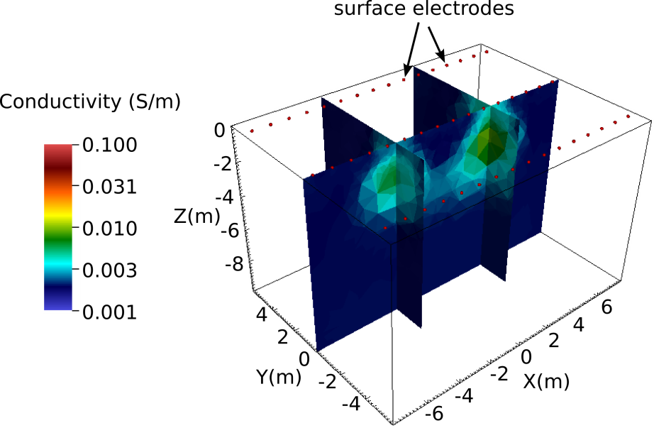
Figure 4. Results of the smoothness constrained inversion with a minimum conductivity constraint provides a slight improvement in resolution over the inversion without the minimum conductivity constraint (Figure 3).

Blocky Inversion
In this example, we assume it is known that, in addition to the minimum conductivity specified in the previous example, the boundaries between subsurface conductivity anomalies are discontinuous, or equivalently, that the conductivity structure is blocky. Because this assumption is consistent with the true model, we expect that providing this information to the inversion will improve imaging resolution. Discontinuous (or blocky) constraints are implemented by instructing the inversion to reduce or remove similarity constraints between neighboring elements that develop a relatively large contrast in conductivity. If the starting model is homogeneous, such contrasts will occur only if demanded by the data. In contrast to similarity constraints that are applied to heterogeneous subsurface, it is possible for discontinuity constraints to obtain a state (through the IRLS method) that is consistent with the subsurface, and thus, with the data. Under such conditions, it is possible for the inversion to converge to a solution that honors both the data and the model constraints, such that it may not be necessary to reduce the beta value in order to fit the data. Such is the case in this example.
In this example, discontinuity constraints are implemented by simply reducing the mean of the weighting function given in the first two constraint blocks (one for zone 1 and one for zone 2) of the previous inversions. By doing so, the constraints are turned off (i.e., given zero weight) when the absolute log conductivity difference between neighboring elements exceeds the mean value of the weighting function. The inversion options file shown below is provided in two_blocks_3.inv.

Inversion Options File: two_blocks_3.inv
<begin two_blocks_3.inv> this line is not included in the file

3 # of constraint blocks, this file implements
1 constrain zone 1 with this block
2 1.0 1.0 1.0 structural metric 2 (wx wy wz ignored)
1 0.1 .05 weight func. 1 with mean of 1.0 and s.d. of 0.05
1 2 one link to zone 2
0.0 reference value (not used)
1.0 relative weight
2 constrain zone 2
2 1.0 1.0 1.0 structural metric 2 (wx wy wz ignored)
1 0.1 0.05 weight func. 1 with mean of 0.1 and s.d. of 0.05
0 no links (already linked to zone 1 above)
0.0 reference value (not used)
1.0 relative weight
1 constrain zone 1 with this block
3 1.0 1.0 1.0 structural metric 3 (wx wy wz ignored)
1 0 .1 weight func. 1 with mean of 0.0 and s.d. of 0.1
0 no links
0.002 reference value (S/m)
2 relative weight
200 0.25 0.5 beta min_red beta_red
1.0 chi_targ
30 50 miniter maxiter
0.00001 1.0 minsig maxsig
2 up_opt
1 3.0 cflag cdev
Notes: This inversion options file implements a blocky inversion by enforcing similarity constraints between neighboring elements (structural metric 2) only if the absolute difference in log conductivity
between elements is (approximately) less than the 0.1, which is the mean of the weighting function. With a standard deviation of 0.05 (i.e., one half of the mean), the weighting function transition between
one and zero is relatively smooth. Zone 1 is linked to zone 2, which specifies that similarity constraints should be applied at the zone 1/zone 2 boundary. Since zone 1 is linked to zone 2, it is not necessary to link zone 2 to zone 1. Hence, zone 2 is not linked to another zone.
The third constraint block implements a minimum conductivity constraint. Weighting function 1, having a mean of zero, turns the constraint on if the value of the structural metric drops below zero, which occurs if the conductivity drops below the reference value of 0.002 S/m. When
the constraint is turned on, the inversion minimizes the structural metric by moving the conductivity toward the reference value (in this case). A relative weight of 2 is specified to ensure the constraint is enforced.
<end two_blocks_3.inv> this line is not included in the file

Running the Inversion
The inversion is executed for this example on 7 cores (1 master and 6 slave) using the command:
<e4d_dir>/bin/mpirun -np 7 <e4d_dir/bin/e4d>.
Or, if mpirun and e4d are in the exectuable path:
mpirun -np 7 e4d.
Upon execution, E4D completes the inversion and reports progress to the following files:
e4d.log: This is primary log file discussed in the next section.
run_time.txt: This file contains run-time information and is updated as the inversion progresses
two_blocks.dpd: This is the predicted data file specified in the output option file two_blocks.out. I
sigma.* Estimated conductivity at the *th inverse iteration.
Status updates are also printed to screen.

E4D Log File: e4d.log
Users are encouraged to run the inversion as specified above (using from 2 to 49 cores), and review the e4d.log file. The inversion converges in four iterations and never reduces the starting beta value. In addition, both the data and model constraint misfits decrease with each successive iteration after iteration 1, demonstrating the agreement between the data and model constraints in this case.

Inversion Image
The blocky inversion image is shown in Figure 5, and displays a marked improvement in imaging accuracy over the previous inversions.

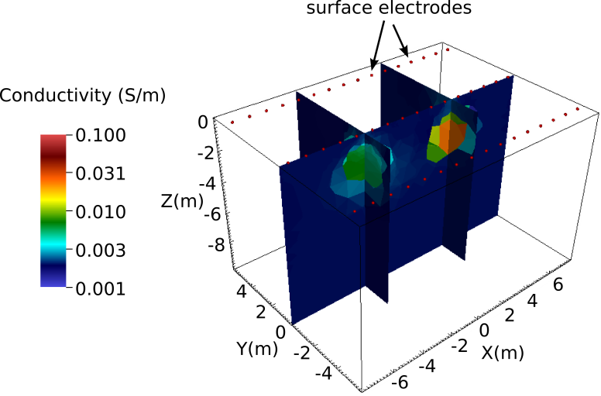
Figure 5. Blocky inversion results display a significant improvement in resolution and converge in approximately 50% of the time required for the smoothness constrained inversions. This demonstrates the value of providing the inversion with prior information through the model constraints.

Discrete Value Inversion
In this example, the inversion is constrained to construct a blocky conductivity structure with only three conductivity values: 0.002 S/m, 0.02 S/m, and 0.2 S/m. There are five constraint blocks. The first two blocks impose blocky constraints in zones 1 and 2, respectively, and the last three impose the discrete value constraints in zone 1. The discrete value constraints use structural metric 3 with weighting function 4. Structural metric 3 provides the log conductivity of an element minus a specified reference value. Weighting function 4 increases as the value of the structural metric approaches the mean of the weighting function. In this case, the mean is zero, so the weighting function increases as the log conductivity of an element approaches the reference value. This effectively causes the inversion to 'snap' the conductivity of elements to one of the reference values specified in the structural metric blocks, depending which value best fits the data. The inversion options file used to implement the constraints is shown below, and is provided with the E4D distribution in two_blocks_4.inv.

Inversion Options File: two_blocks_4.inv
<begin two_blocks_4.inv> this line is not included in the file

5 # of constraint blocks, this file implements

1 constrain zone 1 with this block
2 1.0 1.0 1.0 structural metric 2 (wx wy wz ignored)
1 0.2 .01 weight func. 1 with mean of 0.2 and s.d. of 0.01
1 2 one link to zone 2
0.0 reference value (not used)
1.0 relative weight

2 constrain zone 2
2 1.0 1.0 1.0 structural metric 2 (wx wy wz ignored)
1 0.1 0.01 weight func. 1 with mean of 0.1 and s.d. of 0.01
0 no links (already linked to zone 1 above)
0.0 reference value (not used)
1.0 relative weight

1 constrain zone 1 with this block
3 1.0 1.0 1.0 structural metric 3 (wx wy wz ignored)
4 0.0 0.5 weight func. 1 with mean of 0.0 and s.d. of 0.5
0 no links
0.002 reference value (S/m)
1 relative weight

1 constrain zone 1 with this block
3 1.0 1.0 1.0 structural metric 3 (wx wy wz ignored)
4 0.0 0.5 weight func. 1 with mean of 0.0 and s.d. of 0.5
0 no links
0.02 reference value (S/m)
1 relative weight

1 constrain zone 1 with this block
3 1.0 1.0 1.0 structural metric 3 (wx wy wz ignored)
4 0.0 0.5 weight func. 1 with mean of 0.0 and s.d. of 0.5
0 no links
0.2 reference value (S/m)
1 relative weight
50 0.1 0.75 beta min_red beta_red
1.0 chi_targ
30 50 miniter maxiter
0.00001 1.0 minsig maxsig
2 up_opt
1 3.0 cflag cdev
Notes: This inversion options file implements a blocky inversion by enforcing similarity constraints between neighboring elements (structural metric 2) only if the absolute log conductivity difference
between elements is approximately less than 0.2, which is the mean of the weighting function. With a standard deviation of 0.01, the weighting function transition between one and zero is relatively abrupt.
Zone 1 is linked to zone 2, which specifies that similarity constraints should be applied at the zone 1/zone 2 boundary. Since zone 1 is linked to zone 2, it is not necessary to link zone 2 to zone 1. Hence, zone 2 is not linked to another zone.
The last 3 constraint blocks provide discrete value constraints, which encourage the inversion to 'snap' the log conductivity of an element to a reference value if the log conductivity of that elements is near the reference value, depending on the value of the weighting function standard deviation. The reference values in this example are 0.002, 0.02 and 0.2 S/m.
<end two_blocks_4.inv> this line is not included in the file

Running the Inversion
The inversion is executed for this example on 7 cores (1 master and 6 slave) using the command:
<e4d_dir>/bin/mpirun -np 7 <e4d_dir/bin/e4d>.
Or, if mpirun and e4d are in the exectuable path:
mpirun -np 7 e4d.
Upon execution, E4D completes the inversion and reports progress to the following files:
e4d.log: This is primary log file discussed in the next section.
run_time.txt: This file contains run-time information and is updated as the inversion progresses
two_blocks.dpd: This is the predicted data file specified in the output option file two_blocks.out.
sigma.* Estimated conductivity at the *th inverse iteration.
Status updates are also printed to screen.

Inversion Image
The inversion results are shown in Figure 6. As illustrated, the inversion was able to fit the data to the target chi-squared value using only two conductivity values (0.002 and 0.02 S/m), with the exception of a few elements in the 0.2 S/m block. The block boundaries are well recovered in comparison to the smooth inversion, which demonstrates the value of including prior information in the form of model constraints in terms of improving resolution.
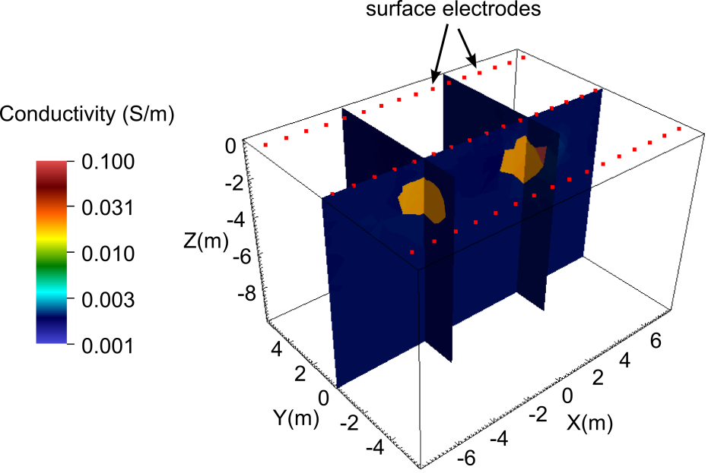
Figure 6. Constrained value inversion, whereby the inversion is constrained to produce a solution with only 3 conductivity values (0.002, 0.02, and 0.2 S/m).

